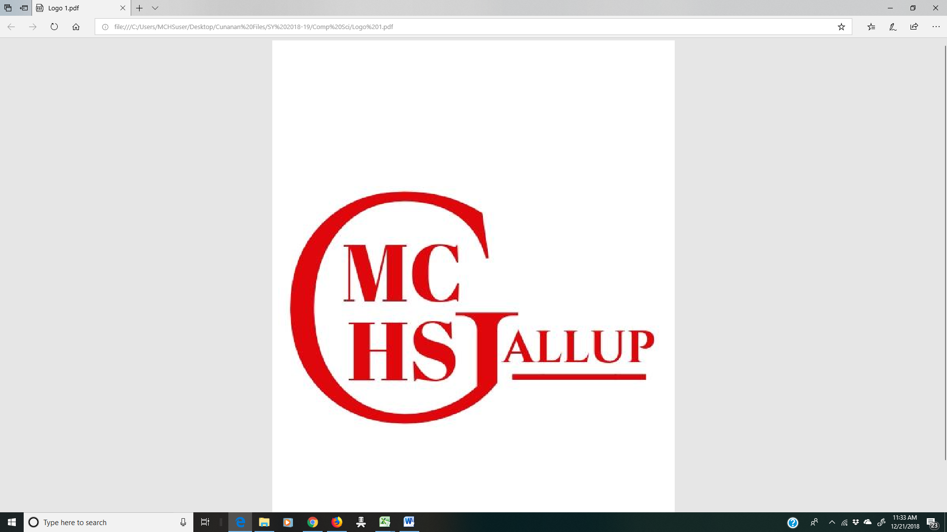

***MIDDLE COLLEGE HIGH SCHOOL***

**MIDDLE COLLEGE HIGH SCHOOL REPORT CARD**

The Charter School Report Card is available at: <https://www.nmvistas.org/Middle_College_High_School_Charter_–_Gallup>

or <https://nmvistas.org>

OVERVIEW

Grades Served: 9-12

Middle College High School received an ESSA designation of **Spotlight School**, meaning that it is among the top 25% of all schools within the state.

SCHOOL PROFICIENCIES

MATH: 17% (compared to 11% state average for high schools)

READING: 38% (compared to 35% state average)

SCIENCE: 57% (compared to 37% state average)

DISTRICT GRADUATION RATES

4-YEAR: >90.0% (compared to 76.7% state average)

***UNM GALLUP, 705 GURLEY AVE- GALLUP, NEW MEXICO 87301 –www.mchsgallup.com***